# Segment 3: Customer Analysis:

1. Calculate the total number of customers.

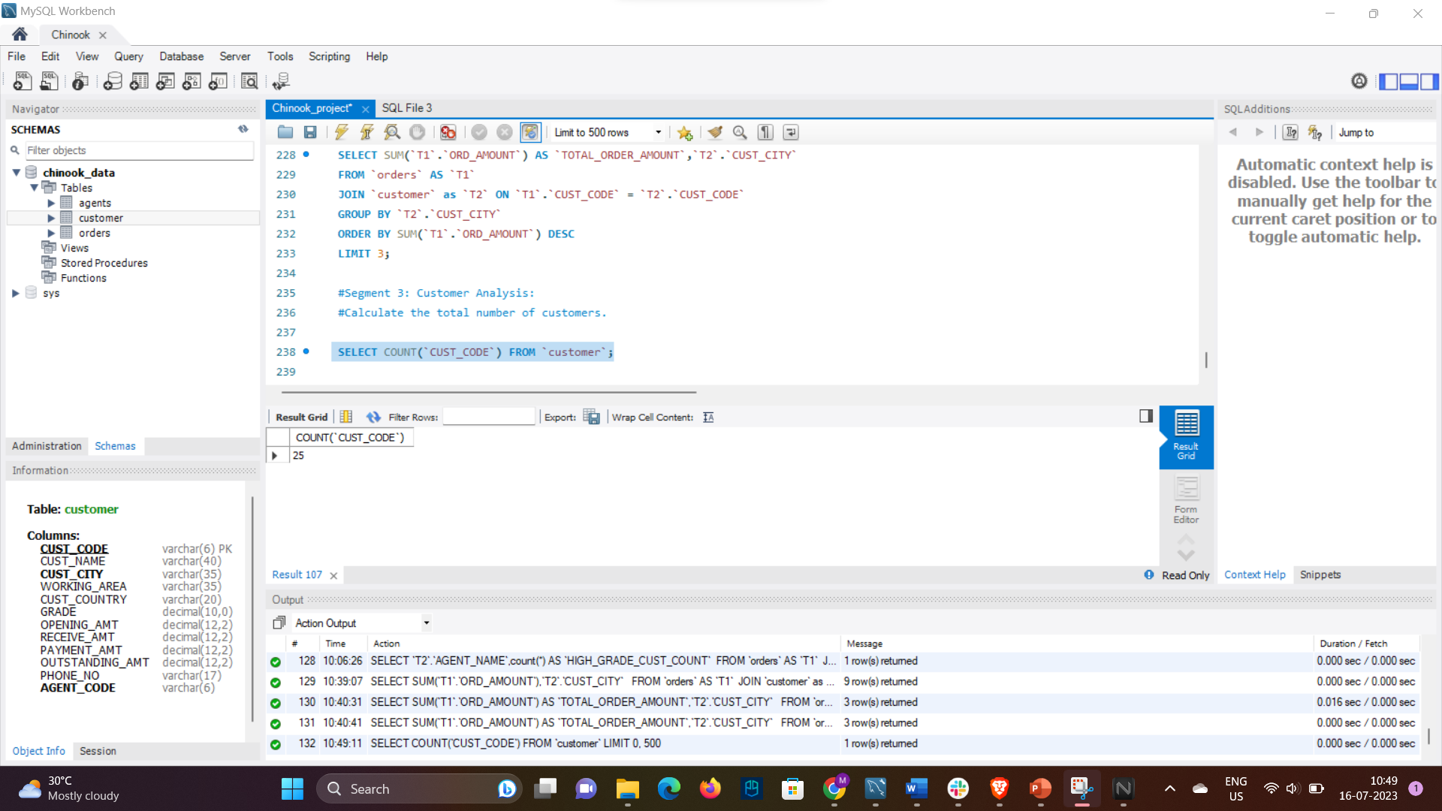

Identify the top-spending customers based on their total order value.

Analyse customer retention by calculating the percentage of repeat customers.

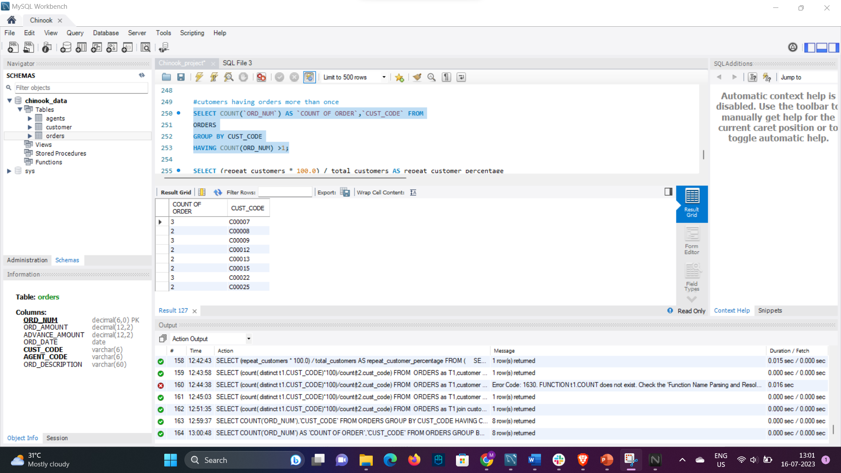

* Find the name of the customer who has the maximum outstanding amount from every country.

* Write a SQL query to calculate the percentage of customers in each grade category (1 to 5).

